Overview: Conceptual model, object level. 1

Class diagrams 3

GradingAssignment object: 4

GradingAssignmentScore object: 6

StudentGrade object: 8

LearningStandardType 10

MarkValueInfo 12

# Overview: Conceptual model, object level.



Note that the association of students with assignment scores and drafts (the students who submit assignments or assignment drafts for scoring) is determined by the membership of those students in the classes that the assignment has been assigned to.

|  |  |
| --- | --- |
| A Grading Assignment is assigned to a Class | GradingAssignment, TeachingGroup |
| A Grading Assignment is delivered through an Assessment Form | GradingAssignment, AssessmentForm |
| A Grading Assignment is expected to receive an Assignment Score | GradingAssignmentScore, GradingAssignment |
| A Grading Assignment receives an Assignment Score | GradingAssignmentScore, GradingAssignment |
| An Assignment Score is achieved by a Student | GradingAssignmentScore, StudentPersonal |
| A Student receives a Grade | StudentPersonal, StudentGrade* |
| A Grade encompasses an Assignment Score | GradingAssignmentScore, StudentGrade* |
| A Grade covers a Term | StudentGrade*, TermInfo |
| A Grade assesses performance against a Learning Standard | StudentGrade*, LearningStandardItem |
| A Grading Assignment assesses performance against a Learning Standard | GradingAssignment, LearningStandardItem |
| A Grading Assignment is marked against a Marking Rubric | GradingAssignment, MarkingRubric* |
| An Assignment Score is scaled according to a Mark Value | GradingAssignmentScore, MarkValueInfo* |
| A Grade is scaled according to a Mark Value | StudentGrade*, MarkValueInfo* |
| A Learning Standard is issued by a Learning Standard Authority | LearningStandardItem, LearningStandardAuthority* |
| A Student submits an Assignment Draft | StudentPersonal, AssignmentDraft* |
| A Grading Assignment has an Assignment Draft | GradingAssignment, AssignmentDraft* |
| An Assignment Draft can receive an Assignment Score | AssignmentDraft*, GradingAssignmentScore |

# Class diagrams

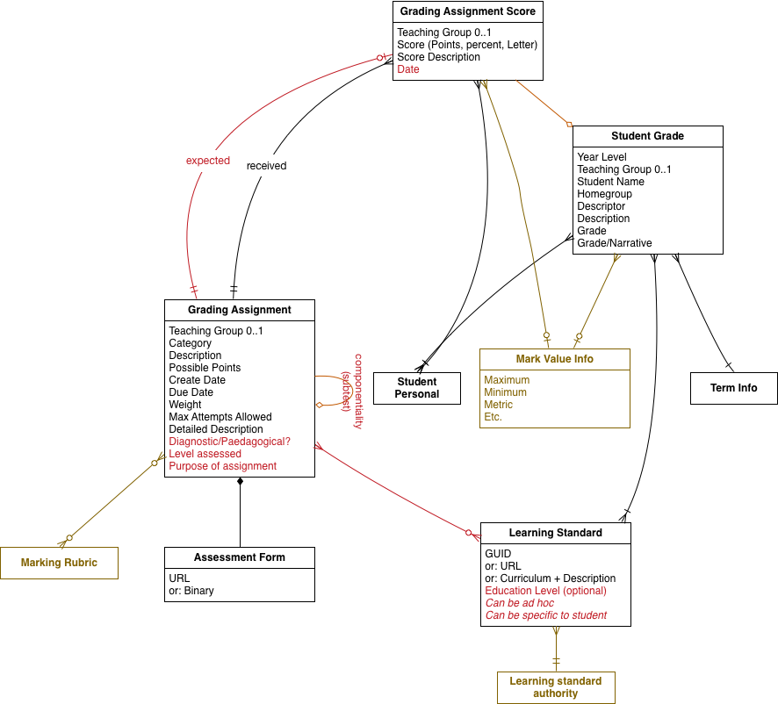

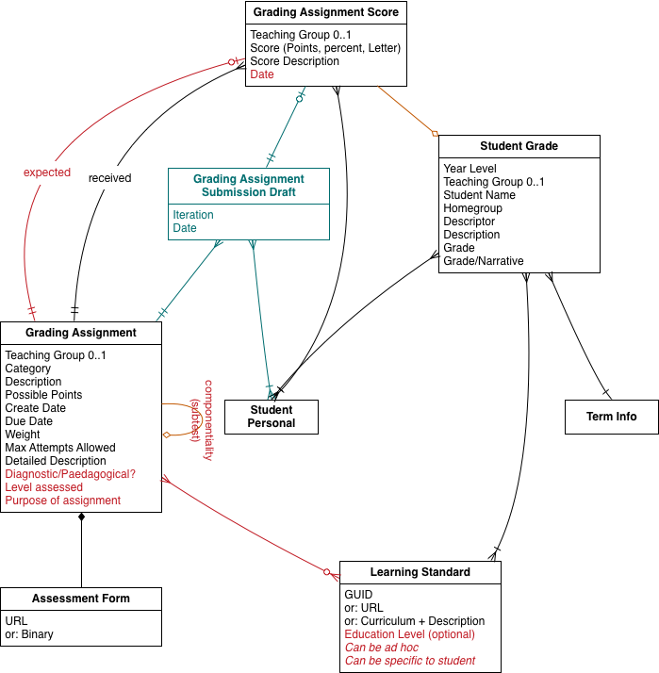

# GradingAssignment object:

|  |  |  |  |
| --- | --- | --- | --- |
| **Element/@Attribute** | **Char** | **Description** | **Type** |
| **GradingAssignment** |  | This object provides information about a particular assignment, allows applications to synchronize each other's assignment tables, gathers the definition for a GradingAssignmentScore object, etc. |  |
| @RefId | M | A GUID that identifies an instance of this object. | [RefIdType](http://specification.sifassociation.org/Implementation/AU/3.4/5/CommonTypes.html#RefIdType) |
| TeachingGroupRefId | O | The GUID for the TeachingGroup object in which this assignment has been set. | [IdRefType](http://specification.sifassociation.org/Implementation/AU/3.4/5/CommonTypes.html#IdRefType) |
| SchoolInfoRefId | O | The Id (GUID) that uniquely identifies the School in which this assignment has been set. | [IdRefType](http://specification.sifassociation.org/Implementation/AU/3.4/5/CommonTypes.html#IdRefType) |
| GradingCategory | O | A particular grading category for the assignment, used to provide grouping and type information. | [xs:normalizedString](http://www.w3.org/TR/xmlschema-2/#normalizedString) |
| Description | M | The text-based description of the assignment. | [xs:normalizedString](http://www.w3.org/TR/xmlschema-2/#normalizedString) |
| PointsPossible | M | The points possible on the assignment. | [xs:unsignedInt](http://www.w3.org/TR/xmlschema-2/#unsignedInt) |
| CreateDate | O | Creation date of the assignment. | [xs:date](http://www.w3.org/TR/xmlschema-2/#date) |
| DueDate | O | Date the assignment is due. | [xs:date](http://www.w3.org/TR/xmlschema-2/#date) |
| Weight | O | The weight of the assignment. | [xs:decimal](http://www.w3.org/TR/xmlschema-2/#decimal) |
| MaxAttemptsAllowed | O | How many attempts the student is allowed on the assignment (applicable particularly to online activities). | [xs:integer](http://www.w3.org/TR/xmlschema-2/#integer) |
| DetailedDescriptionURL | O | The location of the document that describes the assignment. If Type is PDF, this element will contain the Base64 encoding of the entire document. Preferred against DetailedDescriptionBinary for online assessment. | [xs:anyURI](http://www.w3.org/TR/xmlschema-2/#anyURI) |
| DetailedDescriptionBinary | O | The Base64 encoding of a document (e.g. PDF) describing the assignment. | [xs:base64Binary](http://www.w3.org/TR/xmlschema-2/#base64Binary) |
| AssessmentType | O | Type of assessment (e.g. diagnostic vs paedagogical) | xs:token |
| LevelAssessed | O | Level at which assessment is aimed; may be year level | xs:token |
| AssignmentPurpose | O | Purpose for assignment | xs:normalizedString |
| SubAssignmentList | O |  |  |
| SubAssignmentList/GradingAssignmentRefId | MR | Assignments which this assignment is composed of | IdRefType |
| LearningStandardsList | OR |  |  |
| LearningStandardsList/LearningStandard | M |  | LearningStandardType |
| SIF_Metadata | O |  | [SIF_MetadataType](http://specification.sifassociation.org/Implementation/AU/3.4/5/CommonTypes.html#SIF_MetadataType) |
| SIF_ExtendedElements | O |  | [SIF_ExtendedElementsType](http://specification.sifassociation.org/Implementation/AU/3.4/5/CommonTypes.html#SIF_ExtendedElementsType) |

# GradingAssignmentScore object:

|  |  |  |  |
| --- | --- | --- | --- |
| **Element/@Attribute** | **Char** | **Description** | **Type** |
| **GradingAssignmentScore** |  | This object provides score information about a particular assignment. |  |
| @RefId | M | A GUID that identifies an instance of this object. | [RefIdType](http://specification.sifassociation.org/Implementation/AU/3.4/5/CommonTypes.html#RefIdType) |
| StudentPersonalRefId | O | The GUID for the student whose score this is. | [IdRefType](http://specification.sifassociation.org/Implementation/AU/3.4/5/CommonTypes.html#IdRefType) |
| StudentPersonalLocalId | M | The Local Id for the student whose score this is. | [LocalIdType](http://specification.sifassociation.org/Implementation/AU/3.4/5/CommonTypes.html#LocalIdType) |
| TeachingGroupRefId | O | The GUID for the TeachingGroup object in which this assignment has been set. | [IdRefType](http://specification.sifassociation.org/Implementation/AU/3.4/5/CommonTypes.html#IdRefType) |
| SchoolInfoRefId | O | The Id (GUID) that uniquely identifies the School in which this assignment has been set. | [IdRefType](http://specification.sifassociation.org/Implementation/AU/3.4/5/CommonTypes.html#IdRefType) |
| GradingAssignmentRefId | M | The grading assignment for which this score has been received. | [IdRefType](http://specification.sifassociation.org/Implementation/AU/3.4/5/CommonTypes.html#IdRefType) |
| DateGraded | O | Date the assignment was graded | xs:date |
| ExpectedScore | M | If true, this is the expected or calculated score for the assignment. If false, this is the score the student received through attempting the assignment. | xs:boolean |
| ScorePoints | C | The score represented as points. Conditionally required that one or more of ScorePoints, ScorePercent or ScoreLetter must be filled in. For online assignments, ScorePoints should be used to the exclusion of other scores. | [xs:unsignedInt](http://www.w3.org/TR/xmlschema-2/#unsignedInt) |
| ScorePercent | C | The score represented as a percent. Conditionally required that one or more of ScorePoints, ScorePercent or ScoreLetter must be filled in. | [xs:decimal](http://www.w3.org/TR/xmlschema-2/#decimal) |
| ScoreLetter | C | The score represented as a letter grade. Conditionally required that one or more of ScorePoints, ScorePercent or ScoreLetter must be filled in. | [xs:token](http://www.w3.org/TR/xmlschema-2/#token) |
| ScoreDescription | O | Text description of the score. | [xs:normalizedString](http://www.w3.org/TR/xmlschema-2/#normalizedString) |
| MarkValueInfoRefId | O | Interpertation of Grade | IdRefType |
| SIF_Metadata | O |  | [SIF_MetadataType](http://specification.sifassociation.org/Implementation/AU/3.4/5/CommonTypes.html#SIF_MetadataType) |
| SIF_ExtendedElements | O |  | [SIF_ExtendedElementsType](http://specification.sifassociation.org/Implementation/AU/3.4/5/CommonTypes.html#SIF_ExtendedElementsType) |

# StudentGrade object:

* Rationale: Convey student grade/mark for an assessment. Assessment should be defined by reference to a curriculum and strand, and (optionally) a teaching group. Include references to TermInfo (reporting period) and curriculum+strand concepts

Based on SIF-US StudentGrade, SectionMarkInfo. StudentGrade is a grade in isolation, not linked to an assessment, section, or curriculum. SectionMarkInfo is contextualised to a marking period, but contains multiple marks (MarkInfo), each associated with a score (MarkValueInfo)

|  |  |  |  |
| --- | --- | --- | --- |
| StudentGrade |  |  |  |
| @RefId | M | RefIdType |  |
| StudentPersonalRefId | M | IdRefType |  |
| HomeGroup | O | xs:normalizedString | Home group that the student belongs to. |
| YearLevel | O | YearLevelType | Year level of student |
| TeachingGroupRefId | O | IdRefType | The Teaching Group in which this grade was assigned. |
| TeachingGroupShortName | O | xs:normalizedString | Short free format label that describes the teaching group. |
| SchoolInfoRefId | M | IdRefType |  |
| TermInfoRefId | M | IdRefType | Period over which grade is calculated. StudentGrade is intended to range over work done through a marking period; it is not intended for one-off pieces of formative assessment. |
| Description | O | xs:token | The scope of the StudentGrade. Should be used if no TeachingGroup is associated with the grade. |
| LearningStandardsList | OR |  |  |
| LearningStandardsList/LearningStandard | M | LearningStandardType | We will now allow this in 3.4 to be either a GUID to LearningStandatrdItem, or a URL to the National Curriculum. This can be a content description or a strand. VELS… well, let’s talk about how to get VELS into these structures |
| GradingAssignmentScoreList | O | List | Assignments that the student went through to achieve this summative assessment |
| GradingAssignmentScoreList /GradingAssignmentScoreRefId | MR | IdRefType | Grading assignment score included in this grade |
| GradingAssignmentScoreList/Weight | O | xs:decimal | Weight of assignment towards final score |
| Grade | M |  |  |
| Grade/Percentage | C | xs:decimal xs:minInclusive:0.00 xs:maxInclusive:100.00 |  |
| Grade/Numeric | C | xs:decimal |  |
| Grade/Letter | C | xs:token |  |
| Grade/Narrative | O | xs:normalizedString | Comment |
| Grade/MarkValueInfoRefId | O | IdRefType |  |

# LearningStandardType

|  |  |  |  |
| --- | --- | --- | --- |
| LearningStandardType |  |  |  |
| LearningStandardItemRefId | C | GUID of a LearningStandardItem object, presenting the learning standard as part of a well-defined hierarchy (which a client would need to recover and reconstruct). | IdRefType |
| LearningStandardURL | C | URL allocated to the learning standard (e.g. in the Machine Readable Australian Curriculum) | xs:anyURI |
| LearningStandardDescription | C | Learning Standard expressed as a description. |  |
| LearningStandardDescription/Curriculum | O | Curriculum that the Learning Standard belongs to; e.g. VELS. List may include standards from different curricula. | xs:normalizedString |
| LearningStandardDescription/StatementList | M | Statement of the Learning Standard, as a hierarchical list; depth of hierarchy exposed is at the discretion of the sender | xs:normalizedString |
| LearningStandardDescription/StatementList/Statement | MR |  |  |
| LearningStandardDescription/StatementList/Statement/Value | M | Value of statement; e.g. “Algebra” | xs:normalizedString |
| LearningStandardDescription/StatementList/Statement/LevelName | O | Level name; e.g. “Strand” | xs:normalizedString |
| LearningStandardDescription/StatementList/Statement/Level | O | Hierarchical ranking of level | xs:int |
| YearLevels | O |  | YearLevelsType |

# MarkValueInfo

US object, placeholder for future Australian object

|  |  |  |  |  |
| --- | --- | --- | --- | --- |
|  | **Element/@Attribute** | **Char** | **Description** | **Type** |
|  | **MarkValueInfo** |  | This object defines the types of values allowed for a mark and the domain for each mark value. At least one of the Percentage, Numeric, Letter or Narrative nodes must be used to create a valid MarkValueInfo. |  |
| **@** | RefId | M | The Id (GUID) that uniquely identifies this MarkValueInfo entity. | [RefIdType](http://specification.sifassociation.org/Implementation/US/2.7M/html/CommonTypes.html#RefIdType) |
| **@** | SchoolInfoRefId | M | The Id (GUID) that uniquely identifies the School that these Mark Values apply to. | [IdRefType](http://specification.sifassociation.org/Implementation/US/2.7M/html/CommonTypes.html#IdRefType) |
|  | SchoolYear | M | The year that this MarkValueInfo applies to. | [SchoolYear](http://specification.sifassociation.org/Implementation/US/2.7M/html/DataModel.html#SchoolYear) |
|  | YearLevels | O | The year levels that this MarkValueInfo applies to. | YearLevelsType |
|  | Name | M | The text name of the value list ("Letter Grades", "Letter Grades (+/-)", "ESU", "Pass/Fail", "Override Grades", "Citizenship Comment Codes", etc.). | [xs:string](http://www.w3.org/TR/xmlschema-2/#string) |
|  | Percentage | M | Indicates whether a percent Mark is accepted (format ##0.00). |  |
| **@** | IsAccepted | M | Indicates whether a percent Mark is accepted and is used in Change events to unambiguously signal whether support for the Mark has changed, especially ended. | [xs:boolean](http://www.w3.org/TR/xmlschema-2/#boolean) |
|  | Percentage/Minimum | O | The minimum percent value accepted for this mark. If present, the publisher of this object is required to ensure that any values present in the StudentSectionMarks object will not be lower than this value. | [xs:decimal](http://www.w3.org/TR/xmlschema-2/#decimal) |
|  | Percentage/Maximum | O | The maximum percent value accepted for this mark. If present, the publisher of this object is required to ensure that any values present in the StudentSectionMarks object will not be higher than this value. | [xs:decimal](http://www.w3.org/TR/xmlschema-2/#decimal) |
|  | Numeric | M | Indicates whether a raw numeric score is accepted. |  |
| **@** | IsAccepted | M | Indicates whether a raw numeric score is accepted and is used in Change events to unambiguously signal whether support for the score has changed, especially ended. | [xs:boolean](http://www.w3.org/TR/xmlschema-2/#boolean) |
|  | Numeric/Precision | O | Number of significant digits. | [xs:unsignedInt](http://www.w3.org/TR/xmlschema-2/#unsignedInt) |
|  | Numeric/Scale | O | Number of decimal places. | [xs:unsignedInt](http://www.w3.org/TR/xmlschema-2/#unsignedInt) |
|  | Numeric/Low | O | Lowest Mark in the range (e.g., 98, 3.95). | [xs:decimal](http://www.w3.org/TR/xmlschema-2/#decimal) |
|  | Numeric/High | O | Highest Mark in the range (e.g., 100, 4.0). | [xs:decimal](http://www.w3.org/TR/xmlschema-2/#decimal) |
|  | Letter | M | Indicates whether a letter Mark is accepted. | [List](http://specification.sifassociation.org/Implementation/US/2.7M/html/DataModel.html#ActionList) |
| **@** | IsAccepted | M | Indicates whether a letter Mark is accepted and is used in Change events to unambiguously signal whether support for the Mark has changed, especially ended. | [xs:boolean](http://www.w3.org/TR/xmlschema-2/#boolean) |
|  | Letter/ValidMark | CR | List of specific valid letter Marks. May be omitted when IsAccepted is false, otherwise mandatory. |  |
| **@** | SIF_Action | O | In a Change event, this flag can be used to indicate an element has been deleted from the parent list container. At a minimum the key for the list must also be present. | **values:**  Delete |
|  | Letter/ValidMark/Code | M | String representing the actual Mark that would appear on the report card (e.g., "A+", "I", "100"). | [xs:token](http://www.w3.org/TR/xmlschema-2/#token) |
|  | Letter/ValidMark/NumericEquivalent | O | Numeric equivalent for the Mark (e.g., 100, 4.0). | [xs:decimal](http://www.w3.org/TR/xmlschema-2/#decimal) |
|  | Letter/ValidMark/Description | O | The description for this code. (e.g. "Excellent", "Participates in Class", "Incomplete", etc...). | [xs:string](http://www.w3.org/TR/xmlschema-2/#string) |
|  | Narrative | M | If present, indicates that a free-form text narrative is accepted. |  |
| **@** | IsAccepted | M | Indicates whether a narrative is accepted and is used in Change events to unambiguously signal whether support for a narrative has changed, especially ended. | [xs:boolean](http://www.w3.org/TR/xmlschema-2/#boolean) |
|  | Narrative/MaximumSize | O | An integer value representing the maximum number of Unicode characters for the narrative, the UTF-8 encoding of which may be longer. | [xs:unsignedInt](http://www.w3.org/TR/xmlschema-2/#unsignedInt) |
|  | SIF_Metadata | O |  | [SIF_Metadata](http://specification.sifassociation.org/Implementation/US/2.7M/html/DataModel.html#SIF_Metadata) |
|  | SIF_ExtendedElements | O |  | [SIF_ExtendedElements](http://specification.sifassociation.org/Implementation/US/2.7M/html/DataModel.html#SIF_ExtendedElements) |